Adams County Community Services Block Grant (CSBG) Application for Funding

Applications are due by 4:30 P.M. Friday December 22, 2023

# WHO WE ARE:

## WHAT IS THE COMMUNITY SERVICES BLOCK GRANT?

Community Services Block Grant (CSBG) Program provides a range of services and activities having a measurable and potentially major impact on the causes of poverty in the community, or those areas of the community where poverty is a particularly acute problem.

CSBG is funded by the [U.S. Department of Health and Human Services.](https://www.hhs.gov/) The program is administered by the [Colorado Department of Local Affairs (DOLA)](http://dola.colorado.gov/) and by counties for eligible entities for local use.

## COMMUNITY SERVICES BLOCK GRANT MISSION STATEMENT:

To empower Adams County individuals, families, and diverse communities to achieve stability and self-sufficiency by linking and accessing local resources.

# WHAT WE ARE LOOKING FOR:

## PRIMARY CSBG OBJECTIVE

CSBG funds are allocated to non-profit organizations who serve Adams County residents with annual incomes at or below 125% of poverty (2023 Federal Poverty Guidelines attached).

## CSBG FEDERAL OBJECTIVES

The CSBG grant focuses on providing services in the following areas: employment, education and cognitive development, income, infrastructure and asset building, housing, health, and social/behavioral development (includes nutrition), civic engagement and community involvement, services supporting multiple domains (e.g., case management), and emergency management/disaster relief.

Earlier in 2023, we conducted an Adams County Needs Assessment and based on that, we are seeking to fund programs that have a measurable impact on causes of poverty in the community or to those areas of a community in which poverty is a particularly acute problem. Priority will be given to programs that assist individuals with low income around: housing, education, and cognitive development, increasing household income, and any other services leveraging family income and expenses.

Please apply if your organization is:

* Fiscally sound, compliant with 2 CFR Part 200
* Serves Adams County residents with 125% or below poverty levels (refer to 2023 guidelines below)
* Verify and document income and Adams County residence
* Track demographics
* Administrative capacity to track client demographics and services provided, submit reports, invoices and supporting documentation in a timely manner
* Providing services mentioned under the CSBG Federal Objectives

Adams County Community Services Block Grant (CSBG) Application for Additional Funding

1. Organization Name and Unique Entity Identifier (UEI):
2. Organization Mission Statement:
3. Name of Executive Director of Organization:

Phone: E-mail:

1. Name of Project Manager for this project:

Phone: E-mail:

1. Name of Fiscal Contact for this project: Phone: E-mail:
2. All agencies must be able to demonstrate that clients of CSBG programs or services will be low-income individuals and/or families living at 125% Federal Poverty Level or below. Describe how customer eligibility based on Federal Poverty Level is determined, verified, evaluated, and tracked for the purpose of CSBG program activities. Please note that this will be monitored regularly and will need written policies and procedures to determine eligibility for clients to be submitted.
3. All agencies will be required to verify Adams County address for all clients served through CSBG funds. Please note how this will be verified.
4. If the proposed project requires customers to complete an application or there is a selection process (e.g., emergency assistance, human services program, etc.), describe what procedures will be used to ensure customers receiving assistance will be selected through an open and equitable process and that greatest community needs are addressed.
5. Please describe the notification process and grievance procedures for customers who are declined assistance. Policy will need to be submitted.
6. What software system and procedure do you use to track clients?
7. What software system do you use to track finances?
8. Does your agency receive over $750,000 per year in Federal funds? If yes, please include your most current Single Audit with your application.

# I. Program Description

CSBG funded programs are required to report outcomes on various goals the specific program is working on. Please note that this information and its outcomes will be a required report for each end of program year.

Therefore, this information must be as accurate to your program.

1. Description of Project. What specific strategies and services will be employed through the project to address the needs of the individuals to be served.
2. Is this project a new approach or new program that needs seed money for testing or implementation purposes? Yes No

Explain if yes:

1. Amount of CSBG funds being requested per year:
2. How many Adams County unduplicated clients at or below 125% of poverty will be served by this funding per year?
3. Cost per client?
4. Describe the expected outcomes for the clients or community that will be achieved.

Include the projected number of unduplicated clients per year to be served and the projected success rate. Ex. We plan to serve 100 students, with 95 finishing the program.

1. How will success be measured? Include the outcome indicators, the data collection and/or measurement tool, the person(s) responsible for evaluation and the frequency of data and evaluation. Include both quantitative and qualitative evaluation techniques.
2. Adams County may have several non-profit organizations providing this service or a similar service. What makes your organization uniquely qualified to provide this service?

# II. Budget

*Please provide detailed information regarding exactly what you will use grant funding for. Lump sum, one-line item descriptions will not be accepted, unless you are requesting to use these funds on one item only. Please be mindful of your request and all that it will entail. For example, if you are requesting salary, be thoughtful and include any other employee expenditures such as mileage for that employee, office supplies for that employee, etc. This will be your final budget and any changes will need County approval.*

*CSBG PROJECT BUDGET - EXAMPLE*

|  |  |
| --- | --- |
| *Budget Line Items – Activity Costs* | *Amount of County*  *Funds Requested* |
| *Salary: Case Manager* | *$20,000* |
| *Salary: Project Manager* | *$5000* |
| *Operating Supplies* | *$8000* |
| *Travel – Mileage* | *$7000* |

CSBG PROJECT BUDGET

|  |  |
| --- | --- |
| *Budget Line Items – Activity Costs* | *Amount of County*  *Funds Requested* |
|  |  |

|  |  |
| --- | --- |
|  |  |
|  |  |
|  |  |
|  |  |

|  |
| --- |
| Please provide a budget narrative to justify your expenses. |
| *Example using the information above:*  *Salary: Case Manager- Works with clients to determine eligibility, establishes and tracks goals, $20,000*  *Salary: Project Manager- supervise case manager, reports, and other duties Operating Supplies: Office Supplies $8000 folder, copy paper, ink, pens, etc.*  *Mileage – $ 7000 Taking Clients to interviews, housing possibilities and any other assistance that is needed* |
|  |

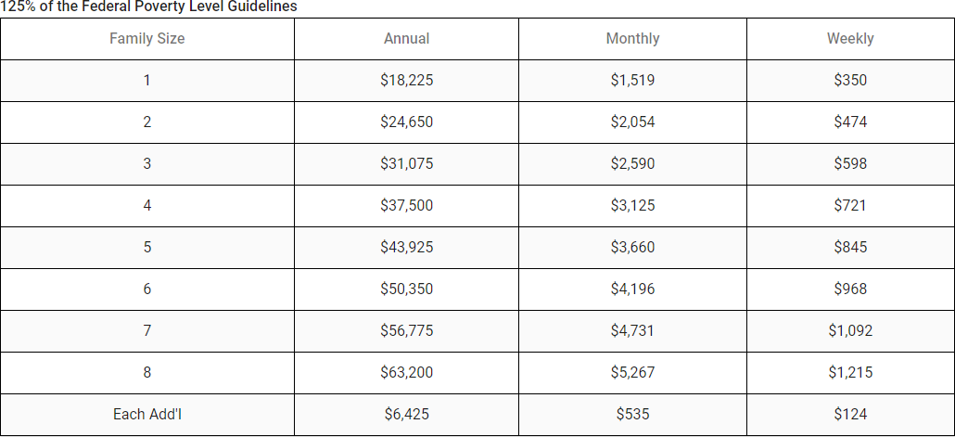

THE APPLICATION MUST BE EMAILED TO efierro@adcogov.org, NO EXCEPTIONS

LATE SUBMISSIONS WILL NOT BE ACCEPTED. SUBMISSION OF APPLICATION IS NOT A GUARANTEE OF FUNDING.

Please answer all required questions as completely and succinctly as possible, check all appropriate boxes, and complete all relevant tables. At our discretion, applicants may be asked to come in for an interview or presentation.

Criteria to be used by Adams County Community Services Block Grant (CSBG) staff and CSBG Advisory Council when reviewing and recommending applicants to Adams County Board of County Commissioners for final approval will be the following:

* Compliance (submitted on time, completed application, fits grant criteria)
* Relationship to county goals and providing services around county’s needs
* Performance Measures
* Organizational Capacity
* Budget (clear explanation on application)

NOTE: Please feel free to contact Adams County CSBG staff at 720.523.6842 for guidance and technical assistance on CSBG regulations, county policies, and application requirements.

DO NOT ALTER THE FORMAT OF THIS APPLICATION

A COMPLETE APPLICATION AND ADDITIONAL REQUESTED DOCUMENTATION MUST BE SUBMITTED IN ORDER FOR YOUR APPLICATION TO BE DETERMINED ELIGIBLE FOR CONSIDERATION

DO NOT ATTACH ANYTHING OTHER THAN AS REQUESTED IN THE INSTRUCTIONS

DO NOT INSERT “SEE SECTION X”, “SEE LETTER”, OR “SEE ATTACHED”

IN ANY SECTION OF THIS APPLICATION

# CHECKLIST

Use this checklist to make sure your Application includes the required documentation.

* One (1) original application containing original signatures and attachments
* Proof of being a Colorado Corporation in good standing
* Proof of 501(c) (3) tax-exempt status from the Internal Revenue Service (IRS)
* Most recently audited financial statements, include Single Audit if applicable
* Board of Directors Information (Occupations and/or Community Affiliations)
* Anti-Discrimination Policy
* Grievance Policy
* Documentation Policies and Procedures
* Names and Qualifications of Key Staff
* Final Certification Form
* Client Eligibility Policies and Procedures